**Repetition:**

**\*** : 0 or more time

**+ :** at least once or more

**? :** 0 or 1 time

**{m} :** For ‘m’ no of occurrence/repetition

**{m, n} :** m -> minimum no of repetition

n -> maximum no of repetition

**{m, } :** Value must appear at least m times..

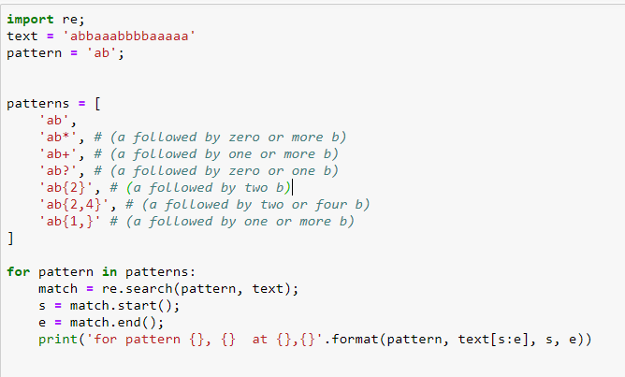

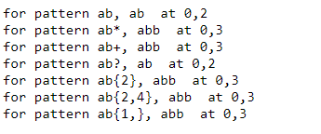

**Character Set:**

A *character set* is a group of characters, any one of which can match at that point in the pattern. For example, [ab] would match either a or b. here we can have any no of characters

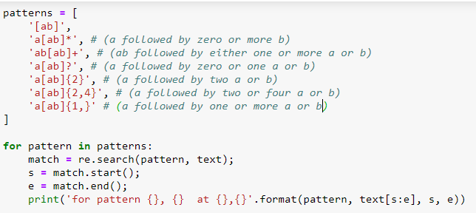

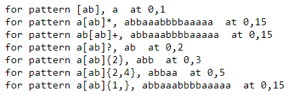

Note: for a[ab]* it consider whole input string, because all the characters in input string are either a or b, if we place any other character let’s say ‘c’, then this will return string only upto character before ‘c’.

A character set can also be used to exclude specific characters. The carat (^) means to look for characters that are not in the set following the carat.

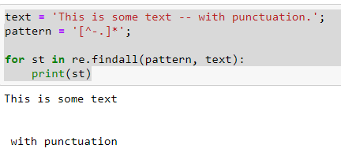

Few more Example:

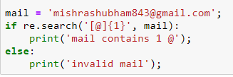



**Ranges in character set:**

*character ranges* can be used to define a character set to include all of the contiguous characters between the specified start and stop points

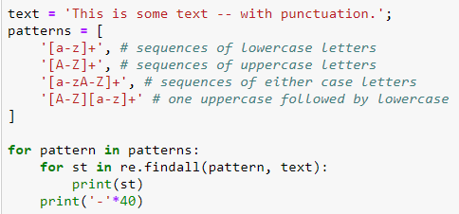

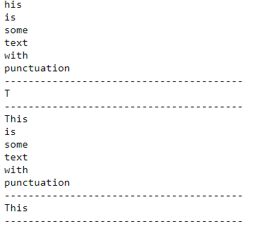

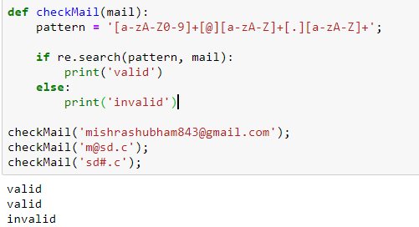

**Dot (.) or period:**

indicates that the pattern should match any single character in that position, Example:

'a.' (a followed by any one character)

'b.' (b followed by any one character)

'a.*b' (a followed by anything, ending in b)

'a.*?b' (a followed by anything, ending in b)

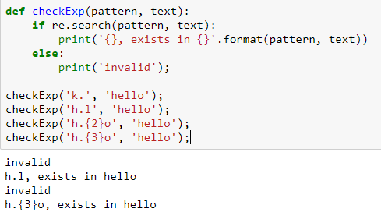

**Escape Codes:**

An even more compact representation uses escape codes for several predefined character sets. The escape codes recognized by re are listed in the table below.

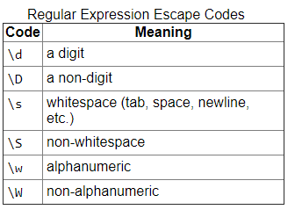

Note

Escapes are indicated by prefixing the character with a backslash (\). Unfortunately, a backslash must itself be escaped in normal Python strings, and that results in difficult-to-read expressions. Using *raw* strings, which are created by prefixing the literal value with r, eliminates this problem and maintains readability.

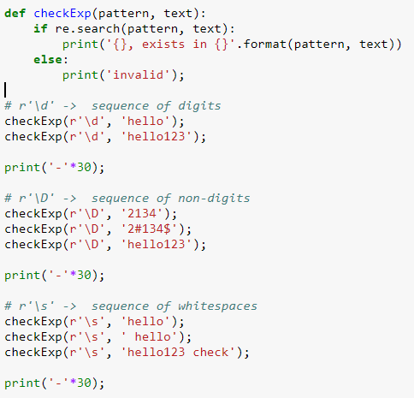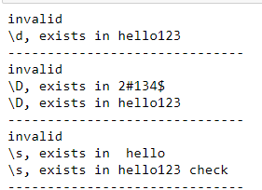

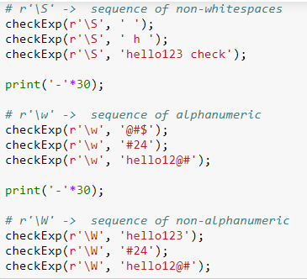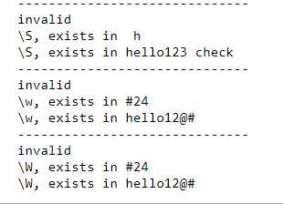

**Anchoring:**

In addition to describing the content of a pattern to match, the relative location can be specified in the input text where the pattern should appear by using *anchoring* instructions. the table below lists valid anchoring codes.

